**Year1**

**Report-Project1**

***BAG HOLDER FOR PRODUCTION BOOST***

**Submitted by:**

Komiljonov Bobur U1910275(19-03)

Kholmurodov Dilshod U1910232(19-03)

Naimov Fayyoz U1910071(19-02)

Mirsagatova Sitora U1910245(19-03)

Zaynobiddinova Zebiniso U1910278(19-03)

|  |  |
| --- | --- |
| ***Team N: 07***  ***Team Name: Lets Help People*** |  |

**School of Computers and Information Engineering**



ABSTRACT.

This report form is about the device which was created to boost the working efficiency. It is a special bag holder for the manufacturing centers where a lot of bags are used. This device is not available in the global market; and it gives a lot of time advantages and can replace the whole worker, benefiting the company’s income.

CONTENTS

ABSTRACT………………………………………………………………………………………………………………………………2

CONTENTS………………………………………………………………………………………………………………………………2

Introduction……………………………………………………………………………………………………………………2

Background…………………………………………………………………………………………………………………………3

New Developments and Principals Achieved…………………………………………5

Structure of report…………………………………………………………………………………………………6

Gantt Chart………………………………………………………………………………………………………………………7

Survey Results………………………………………………………………………………………………………………7

Design Variables…………………………………………………………………………………………………………9

Quality Function Deployment……………………………………………………………………………10

Conceptual Design Project Flow……………………………………………………………………11

Evaluation and Analysis………………………………………………………………………………………14

Decision-Making Matrix…………………………………………………………………………………………15

Final Design……………………………………………………………………………………………………………………16

Conclusion…………………………………………………………………………………………………………………………17

INTRODUCTION.

Specially designed new bag hanger is created to help and

boost the efficiency of production.

There will be special hanging details with the help of which

the hanging bag will be held tight. Also, the built in 4 wheels do the best job in moving the hanger when the mass is too big. The hanger’s endpoints can change so that it can be adjusted to different sized bags.

Till today, there is no such product available in the market and used anywhere in the manufacturing. This device does the best job at helping staff and shortening investments.

The bag hanger can be used at any type of production and exporting processes.

Background.

As it is clear for all of us export is considered as one the

most important fields of the country, since export plays a

crucial role in the country’s economy.

To export products businessman use either boxes or sacks

(packets). While searching we found that boxes arrest much space

compared to sacks. For this reason, it is preferred to use sacks

by many exporters in today’s market.

It is obvious for many of us that to pack products into sacks

two people are needed. We learned both advantages and

disadvantages of making to two people engaged in packing, and

found that its drawbacks outweighs benefits. Initially, it is

waste of money: minimum salary for workers in Uzbekistan is

around 70$. This means that employers should pay to some of

their employees just for holding a sack.(Of course not any

employer wants this). Additionally, it slows down the work

process and as a result exporters may lose much time.

After learning all pros and cons of having two employees

just for packing products we had an idea to create a tool for

them which can help both employees and employers to easy their

work as well as boosting work process. Survey results showed

that customers do not want to use smart devices as smart devices

can result in several misunderstandings among workers while

using it. Considering all customer requirements and drawbacks of

two employees we had an idea to create a simple but useful tool

for customers. Our product will be very simple: it will work as

a stabilization. It will be made of stainless steel which is

very durable and not so expensive. With the help of this tool

only one person can pack the products into sacks as it holds

bags for the workers, this will surely increase the working

efficiency and benefits the business. Additional feature of

this product is that bag holding part can be either made smaller

or bigger due to the size of sacks. Plus, there will be wheels

in it, this helps workers to move it easily from place to place.

As mentioned above, it can replace the worker, the employers who

are using it can save a lot money since they do not have to pay

extra money for the staff monthly just for holding bags.

We believe that our product will be preferred by many

businessman and exporters as it helps them to solve the problems

like cutting down on employees, saving time and most importantly

saving money.

New Developments and Principal Results Achieved.

Our main aim was to create an appropriate technology that

does not exist in global market. The product should be

affordable and it should have very good quality of work

efficiency at the same time. After having online meetings with

our team members and talking with specialists in this sphere on

the phone, we came up with the new idea.

The workers who work in an exporting goods factory said

that they face difficulties in loading goods into bags.

Moreover, the owner (manager) of the factory complained about

how much money he pays to workers for such a small job. Since,

the amount of salary of a worker is very high at such kind of

factories, the manager asked us to come up with the new idea in

loading goods into bags. When we searched for this kind of tool

on the Internet, we could not find any of this kind of tools.

Our conceptual design allows worker to do the same job

(loading goods into bags) by himself while this job was being

done by two workers till now. It saves a lot of money of the

factory and by this it can reach the global market.

Moreover, our new product is very light and also it is

easy to carry around as it has wheels under it. Many people know

that different sizes of bags are used at the factories. So,

taking into account this, we made our tool fit to any kind of

size. The user can adjust to an appropriate size easily.

One more important feature of the product is its

durability. Since we used very durable and stainless profile, it

can be used for several decades.

Finally, it is important to note that after we came up

with this new idea, one of the factories got interested into

this and ordered 2 pieces of our product. Currently, we are

testing our product at that factory and then we try to attract

interests of other factories also.

STRUCTURE OF REPORT.

In this report the steps of the conceptual designing process will be given in the following order:

1. Gantt Chart
2. Survey Results: Customer Complaints and Requirements
3. Design Variables
4. Quality Function Deployment (QFD)
5. Conceptual Design Project Flow
6. Evaluation and Analysis
7. Decision-Making Matrix
8. Final Design

GANTT CHART.

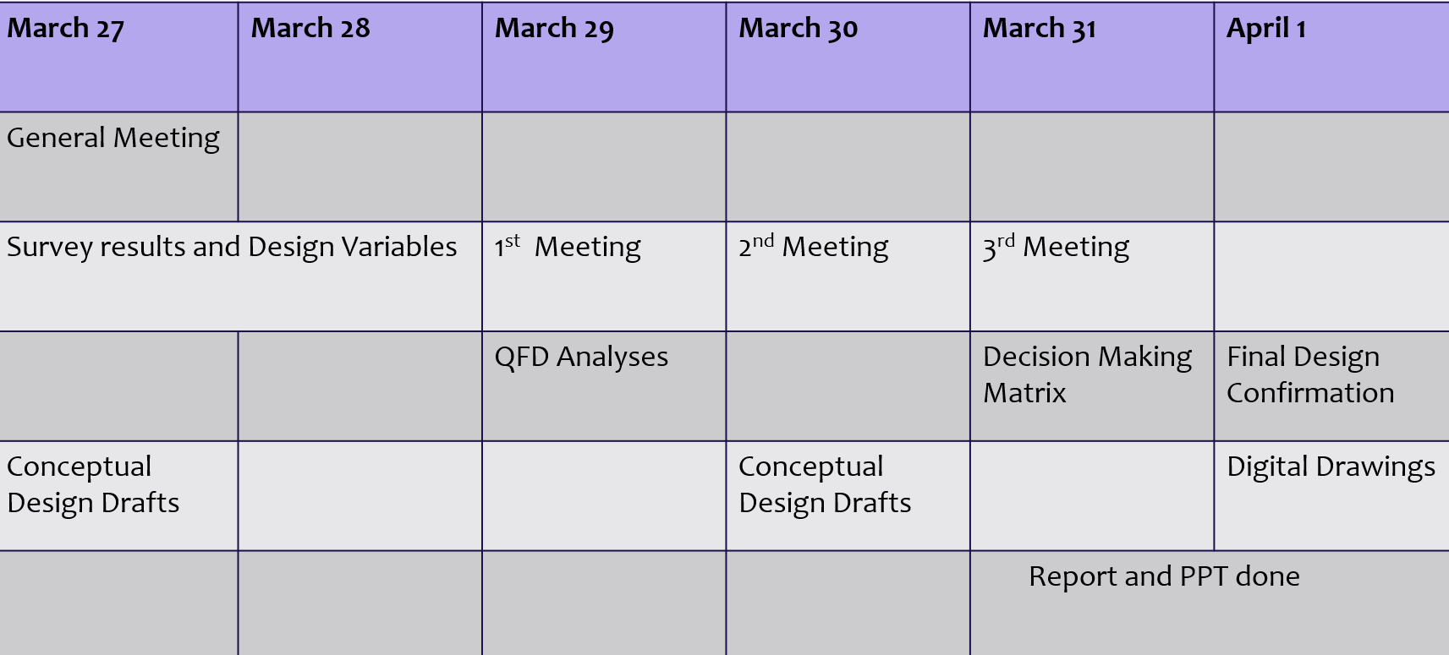

Conceptual Designing Process lasted 6 days, in which 3 online Meetings and one General Meeting (online meeting using ZOOM) was held.

SURVEY RESULTS.

Customer Complaints:

* Factories need extra employees to packaging products.
* In this kind of atmosphere, “More employees mean less profit”.
* Smart machines are difficult to use for new small or huge enterprise factories.
* Device is so expensive to purchase for not only new functionalized factories, but also huge corporations.
* In Uzbekistan, packaging takes much time.
* Nowadays function hasn’t got noticeable work efficiency.
* Sometimes this system isn’t comfortable.
* Workers exchange a lot because work is a bit difficult when there hasn’t got anything to help.

Customer Requirements:

* Want something that needs less employees to packaging(C1)
* Want something which needs less employees and more profit(C2)
* Want something easy to use(C3)
* Want something that is affordable for also new opened factories(C4)
* Want something that helps to package products as quickly as possible(C5)
* Want something that increases work efficiency(C6)
* Want something which is comfortable to use(C7)
* Want something that is durable(C8)

The most obvious solutions to the problems:

* To create a tool that cuts down on extra staff(C1)
* To create a tool that increase profit of company and also country’s economy(C2)
* To create a tool that isn’t so complicated(C3)
* To use materials that are not expensive(C4)
* To create a tool that takes less time to package(C5)
* To think about tool which makes noticeable work efficiency(C6)
* To think about design that is suitable to move, when the mass of packaged product become heavy(C7)
* To use durable materials like stainless profile(C8)

DESIGN VARIABLES.

1. Easy to use: user should not face any difficulties while using

2. Design: the product should attract attention of people

3. Weight: the product should be easy to carry around

4. Cost: the product should be affordable to all people

5. Durable: the product should be usable for a long time

6. work efficiency: the product should be cheap and it should bring significant amount of profit at the same time (appropriate technology)

Customer Requirements:

* Want something easy to use(C1)
* Want something that do not disturb while walking(C2)
* Want something with more than 1-2 functions(C3)
* Want something cheap to purchase(C4)
* Want something that can be used in different weather conditions(C5)
* Want something durable(C6)
* Want something that do not consume much energy(C7)
* Want something with beautiful design(C9)

Quality Function Deployment.

|  |  |  |  |  |  |  |
| --- | --- | --- | --- | --- | --- | --- |
|  | **Convenience** | **Design** | **Weight** | **Cost** | **Durability** | **Work efficiency** |
| C1 C C1 | 7 | 6 | 5 | 8 | 6 | 9 |
| C2 | 8 | 7 | 6 | 7 | 7 | 8 |
| C3 | 7 | 5 | 7 | 8 | 6 | 8 |
| C4 | 7 | 7 | 5 | 6 | 5 | 7 |
| C5 | 9 | 4 | 6 | 9 | 3 | 9 |
| Total | 38 | 29 | 29 | 38 | 27 | 41 |

QFD shows that several features and functions, including convenience, cost and most importantly work efficiency are considered as highly demandable.

CONCEPTIAL DESIGN PROJECT FLOW.

In the beginning of project 2, we decided to give attention

to the atmosphere which is mentioned by president of Uzbekistan,

Shavkat Mirziyoyev . President always says that we have to

export our product around the world, not to import their

different kind of product. We thought that it has a sense. If we

export our own product to other countries, money comes to our

country and companies in our country, not just goes to another

countries which export their products to our country. In

Uzbekistan, more factories put products in boxes, as a result,

it takes much place in exporting. We have to say that some of

them package their product. But, they rely only man power. As a

consequence, it has noticeable problems for companies like

taking extra employees, losing time, not getting enough profit

which is help to maintain their process and etc. Of course, you

can say that around the world have smart machines. But, such

kind of modern machines are so expensive to more companies in

Uzbekistan, not easy to use and not understandable (it takes

also time to learn it) and etc. So, factories need only tool

that helps to make ready product to export on time and making

normal profit.

Well, we decided to create such king of tool which is shown below:

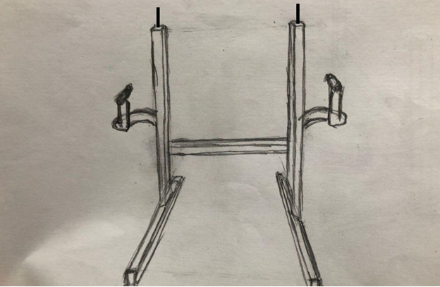

**This is first appearance**, we think that it helps a lot in

packaging and solve all problems which are given in above. If

factories use our product, they only need 2 employees to packaging

their export. And also they can export everything on time and they can

export too many products at once. I can say that it is very easy to

use and understand.

Now you can see below the **second appearance** of our product:

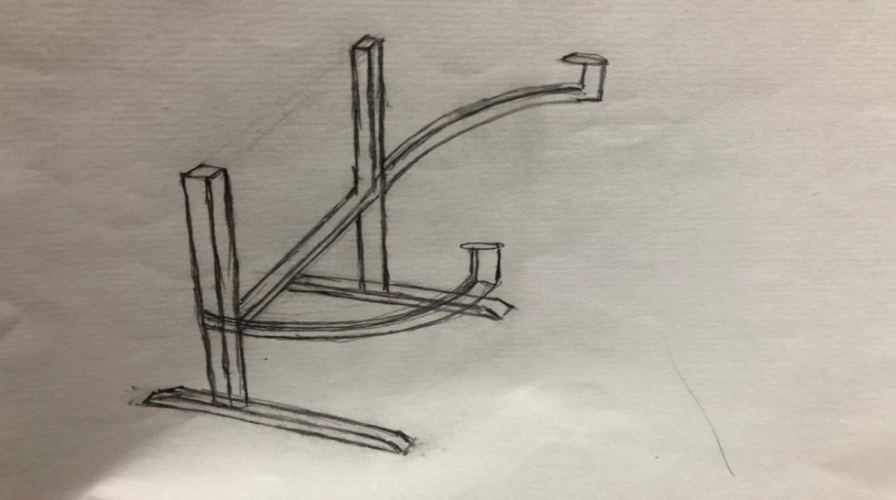

We added some features to make more comfortable to employees in

the process of packaging like wheels. Wheels are added to feet

that helps to move the tool when it is too heavy to lift. I mean

that employees can easily move the product with tool to place

where they combine all ready packaged products thanks to wheels.

And also we make some comfort that they can pack products into

different form of packages, that is tool can be shorten or

lengthen depending on the shape.

**MATERIALS FOR OUR PRODUCT:**

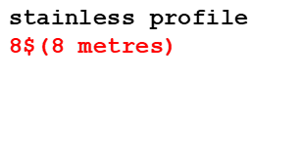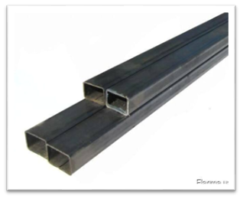

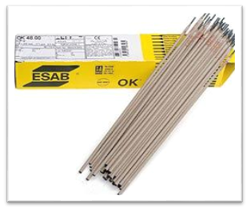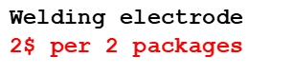

When it comes to materials, you see that it doesn’t need a lot and expensive materials to make. If we trust our calculation that 8metres of stainless profile and 2packages of welding electrode are enough to make ready for sale. And I think more people know that materials are durable and stainless.

Evaluation and Analysis.

1. Easy to use: Positive Effect. Our product is simple to use,

so users do not face to any misunderstanding while utilizing.

1. Design: Positive Effect. Our product will have a unique design as it was never created before.
2. Weight: Positive Effect. Our product will not be heavy to carry, additionally, it will have wheels which helps to move without obstacles.
3. Cost: Positive Effect. Our product will be very cheap.
4. Durability: Positive Effect. Our product will be made of stainless steel which is considered as the durable material in architecture.
5. Work Efficiency: Positive Effect. Our product will be

cheap, durable, easy to use at the same time it can bring considerable profit to the owners.

DECISION MAKING MATRIX.

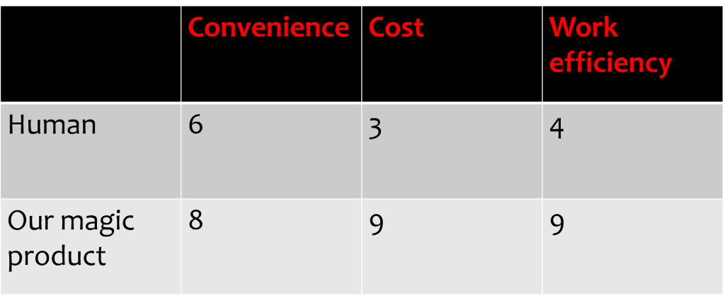

Since we did not find any existing product like ours on a global market, we decided to compare our magic product with human. So, in order to put something into a bag we need at least 2 workers, which is not so comfortable. And that’s why HUMAN got only 6 in CONVENIENCE section. Regarding to the COST it is evident that the average salary of loaders in Uzbekistan is about 70$ and our product costs about 12$.As a result, the employers would be in benefit not only in terms of cost but also in terms of work efficiency because it is adjustable and it has wheels that would help staff to move it and influence positively on a Work Efficiency.

FINAL DESIGN.

* This product would be able to hold the bags for the workers, this will consequently increase the working efficiency and highly benefit the business. One of the additional features of the following product is that the bag holder can be either made smaller or bigger for more comfort in use. The product will have built in wheels that will help the staff move it. This will help the users especially when the bag is full and the weight is too big.
* 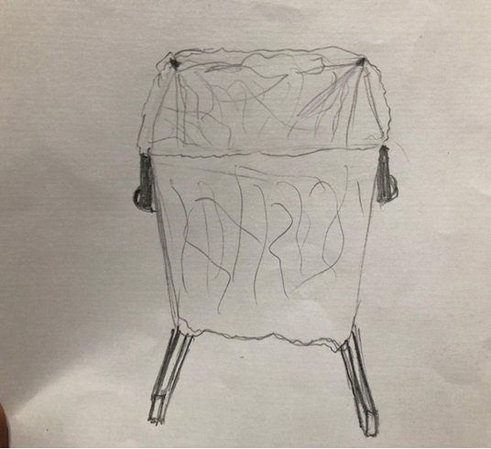

Final design of the product.

As you can see in above, our magic product looks like that. Our team had a target to create the tool which helps to our county’s economy. We hope that we achieved our goal.

CONCLUSION.

* In this Conceptual Design Project team “ Let’s Help People” tried to come up with a NEW idea that will help both employers(Because the product can replace the worker, the business centers which are using it will not have to pay extra money for the work of staff.)and people(if employers reduced the number of employees without decreasing, but rather, even increasing work efficiency, the price for the product will be automatically reduced). Moreover, being supported by last finding, it is forecast that ,the salary of the workers will be increased in nearest future, as a result of the cost of investments for the product, the overall price will be cheap and will be a lot more better choice than hiring a new staff.
* The product is considerably helpful for companies who face a lot competition with other companies in terms of work efficiency and cost of the product and also for companies who do a lot of export(Factories in Central Asia export their products in the continents using bags, because exporting in a box is not profitable. and if they export through boxes, this will lead to a decrease in the number of exported products, which is also unprofitable.)